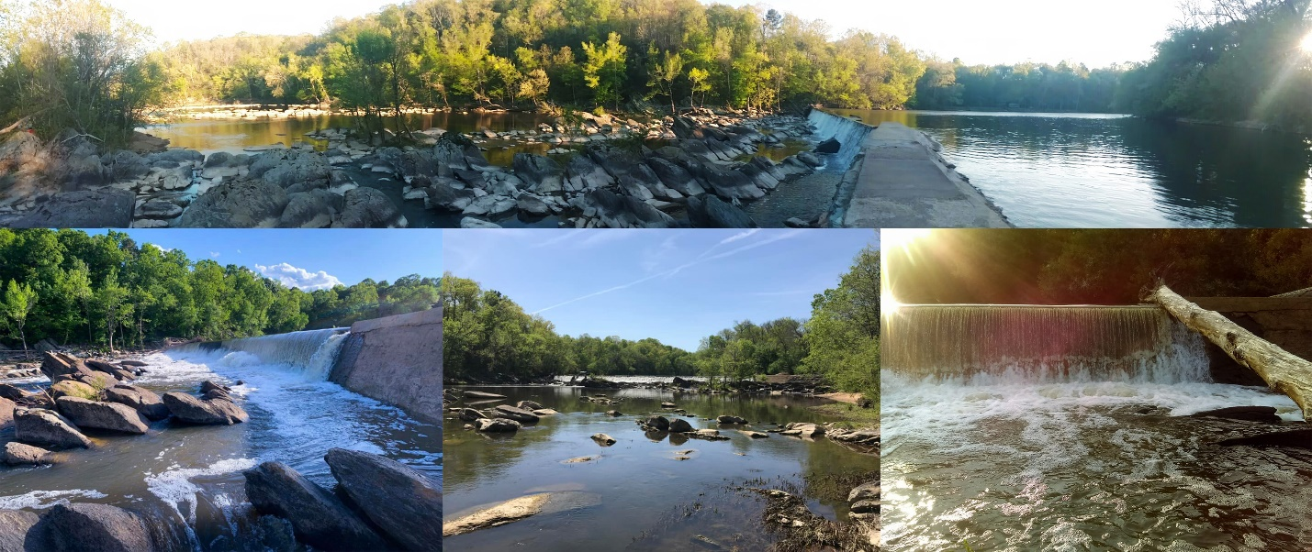

**Petition to Save the High Falls Dam in Moore County, NC**

**Petition Summary:**

Our beloved High Falls Dam has been a part of our community in High Falls, NC for over a century. This dam is not just an infrastructure; it's a symbol of our heritage and unity. It has stood the test of time, witnessing countless seasons change and generations grow.

However, this majestic structure is now under threat of being destroyed. The loss would not only erase a significant piece of our history but could also have potential environmental impacts on local wildlife that depend on the dam's ecosystem.

Furthermore, the impending destruction of our beloved High Falls Dam raises concerns about the well-being of many landowners on the river, who may lose their access to essential well water resources, adding to the already dire consequences of this decision.

**Action Petitioned For:**

We the undersigned are concerned citizens who wish to preserve the High Falls Dam in Moore County, NC.

|  |  |  |  |  |
| --- | --- | --- | --- | --- |
| **Date** | **Signature** | **Printed Name** | **Address** | **Comment** |
|  |  |  |  |  |
|  |  |  |  |  |
|  |  |  |  |  |
|  |  |  |  |  |
|  |  |  |  |  |
|  |  |  |  |  |
|  |  |  |  |  |
|  |  |  |  |  |
|  |  |  |  |  |
|  |  |  |  |  |
|  |  |  |  |  |
|  |  |  |  |  |
|  |  |  |  |  |
|  |  |  |  |  |
|  |  |  |  |  |
|  |  |  |  |  |

**Petition to Save the High Falls Dam in Moore County, NC**